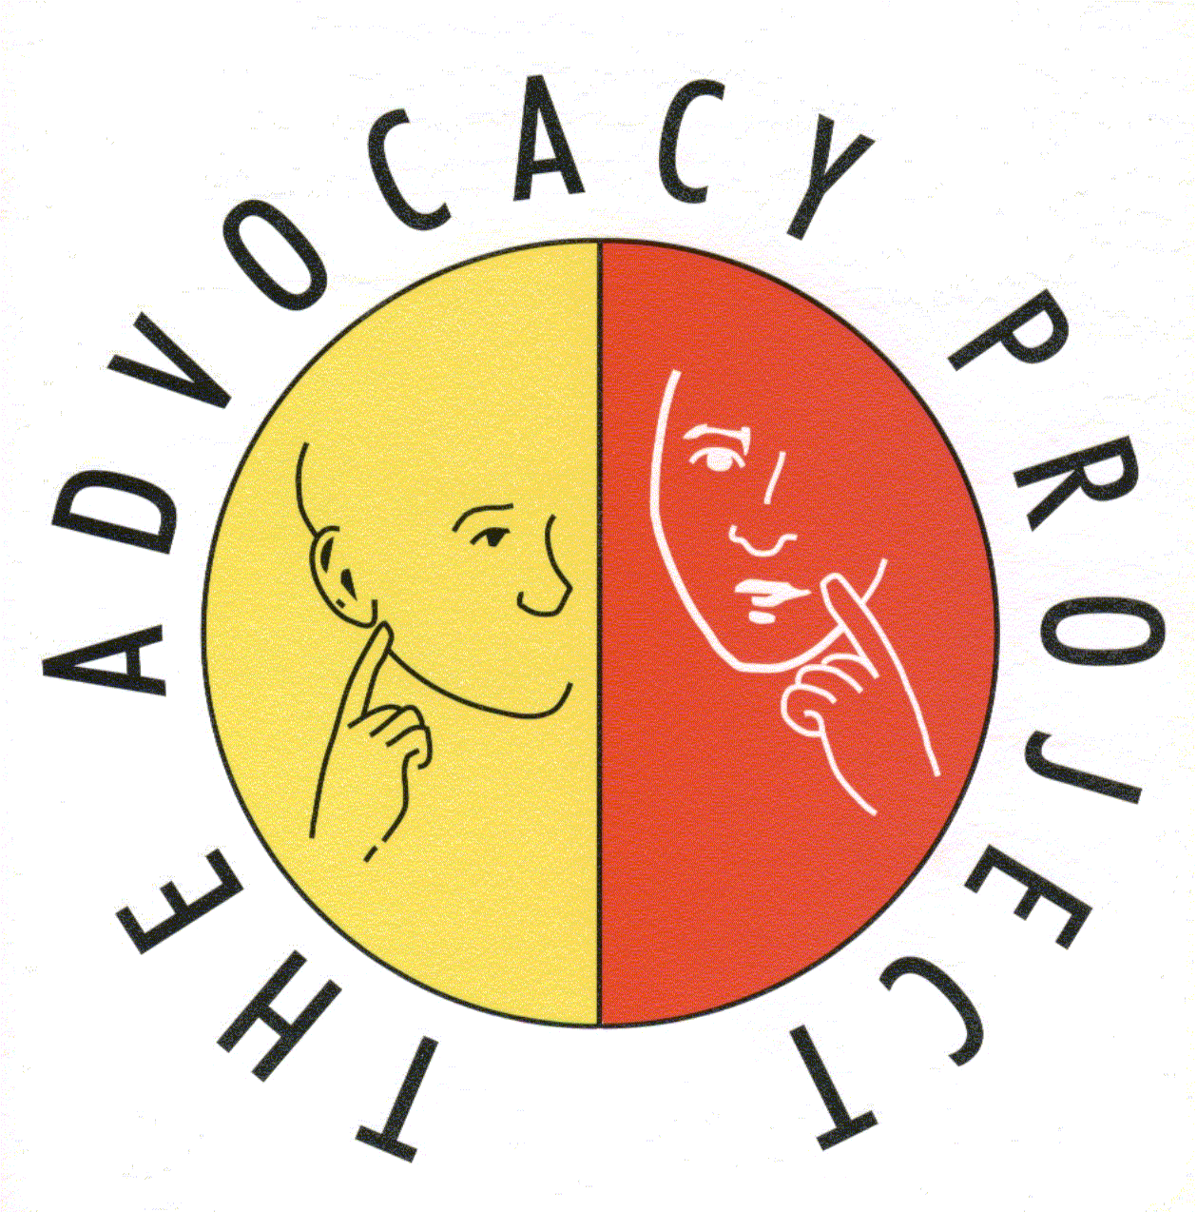

The Advocacy Project

The Advocacy Project has been delivering independent advocacy support to vulnerable people for over 21 years, providing a professional service across West Central Scotland. Due to increases in contractual services and internal development plans the organisation is undergoing a 15 month restructure period, during which it will review its existing operational structure to ensure it can effectively meet the needs of the services it provides going forward from 2015. It is looking to fill the following vacancies

Operations Manager – Full time (£31,926) Based on a fixed term contract to April 2015. Secondment opportunities considered.

To manage effective operational services across Glasgow, you will be responsible for the delivery of advocacy services contracted by GGCNHS & GCC. With a focus on quality you will be managing, leading and motivating a team of advocates, providing support, development and inspiration to ensure our services continue to achieve and improve their high standards.

Service Lead Officer – Full time (£25,682) (2 posts) Based on fixed term contract to April 2015. Secondment opportunities considered.

To lead on the development and implementation of systems and procedures in order to support and improve service quality. As part of the management team you will assist the Operations Managers in the monitoring and reporting of service outcomes in line with contractual requirements.

Further details of The Advocacy Project, its work and these posts is available from our website, www.theadvocacyproject.org.uk

Email : enquiry@theadvocacyproject.org.uk
Telephone: 0141 420 0961

The Advocacy Project strives to be an equal opportunities employer.
This post is subject to a satisfactory PVG Membership
Closing Date for applications 10th March 2014 at 12 noon

Registered Charity No SCO20564/ED644/91

