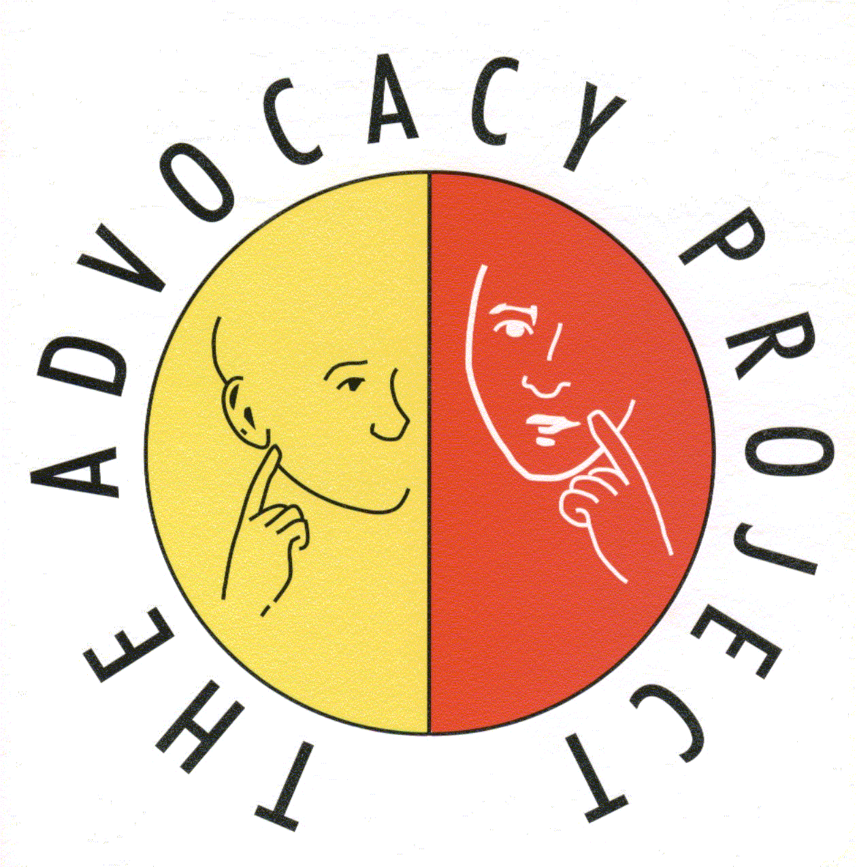

The Advocacy Project

The Advocacy Project has been delivering independent advocacy for over 22 years, providing a professional service across West Central Scotland. Based on the belief that people have the right to be as involved as they can be in decisions which affect their lives and if necessary have their rights safeguarded.

Advocacy Worker (£19,099 - £20,698) (2 posts)

We are looking for motivated, organised and assertive individuals who can uphold the rights of people who are often marginalised, and ensure their voice is heard and listened to.

A demonstrated understanding and commitment to the principles of inclusion, equality and empowerment is required.

Further details of The Advocacy Project, its work and these posts is available from our website, www.theadvocacyproject.org.uk

Email : enquiry@theadvocacyproject.org.uk
Telephone: 0141 420 0961

The Advocacy Project strives to be an equal opportunities employer.
This post is subject to a satisfactory PVG Membership
Closing Date for applications 30th Sept 2014 at 12 noon

Registered Charity No SCO20564/ED644/91

